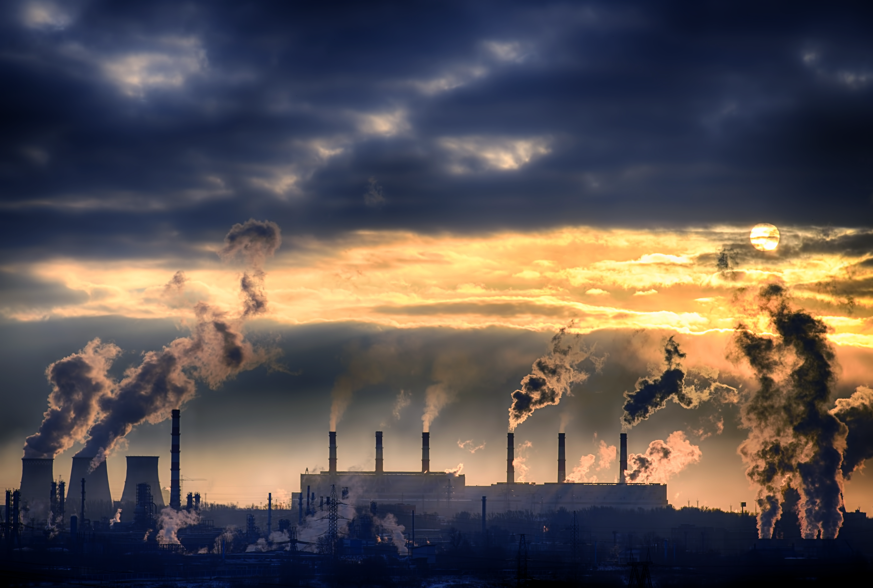

**Problem Statement:**

* which macroeconomic factors the biggest predictors of global warming, i.e. global carbon dioxide emissions.
* analysis is based on year 2014.

Data:

We have data of 62 countries, which contains information on co2 emission per person, GDP per capita income, forest coverage percentage industry percentage of GDP, coal, oil, electricity consumption per capita, population, yearly emission of co2, percent use of nuclear and other renewable energy sources in total energy generation.

**Data Pre-processing:**

*Missing value*:

There were few missing values, imputed using sklearns iterative imputer.

*Outlier treatment:*

* Observed that most of the variables are skewed. It was expected. As some country’s population, GDP, co2 emission is very high compare to rest.
* We capped outliers at 99th percentile.

*EDA:*

* income_per_person_gdppercapita_ppp_inflation_adjusted, coal consumption, electricity generation and use per person, oil consumption per person shows positive trend with co2 emission.
* these variables might be helpful for predicting co2 emission.
* from above heatmap we can see that income per person GDP per capita, electricity generation and use, oil consumption are highly corelated with target variable co2 emission per capita.
* we can also observe multi-collinearity in the data. like import and export are highly corelated. electricity use and generation are also highly corelated with income per GDP per capita.
* From above plot we can see that contribution of Qatar is highest in c02 emission per person.
* we can also see if we consider co2 emission per person in 2014 Qatar, Kuwait, United Arab Emirates was on an avg. 25.31 tones per capita which was way above the rest of the countries avg. which was 6.34 tons per capita.

*Scaling:*

Used standard scaler to scale the data.

**Model Building:**

*Lasso regression:*

After hyper parameter tuning found regularization parameter to be 0.01, got a R squared value of 87%. With some feature elimination.

**Findings:**

* *electricity_use_per_person, industry_percent_of_gdp, oil_consumption_per_cap, coal_consumption_per_cap these are the variable positively effecting the co2 emission.*
* *we can interpret them like, if we increase electricity_use_per_person by one unit by keeping all other variable constant co2 emission per capita increases by 0.524 unit.*
* *forest_coverage_percent, eg_use_comm_cl_zs these are the variable negatively affecting the co2 emission.*
* *we can interpret them like, if we increase forest_coverage_percent by one unit by keeping all other variable constant co2 emission per capita decreases by 0.148 unit.*

**Conclusion:**

* electricity use per person
* percentage contribution of industry sector to gdp
* oil consumption per capita
* coal consumption per capita
* increase in these features causes to co2 emission per capita to increase.
* coal, gas, oil contribute about 64% of the electricity generation in the world. as the energy produced by these resources is not a clean one and we in our analysis we also find out use of these resources increases co2 emission.
* today’s economy is also an oil driven economy, our industries are also very much dependent upon these unclean energy sources so, growth in industrial sector also leads to greater increase in co2 emission.

**===============================================================================================**

we can also see that,

* percentage of area covered by forest
* percentage alternate and nuclear energy resources in total energy generation
* increase in these features causes to decrease in co2 per capita emission.
* very large amount of co2 is trapped in the forest, if we increase deforestation it will lead to release of more co2 in the environment. we need to increase the forest cover to increase natures capacity to trap co2.
* wind, solar, geothermal, tidal, etc renewable energy resources and nuclear energy generates clean energy, which does not emit co2. we can see from analysis these two features negatively impacting the emission to co2. we need to focus on these clean energy resources to bring down co2 emission.